Lab 21: Calorimetry

Group Submission
Yoaneli Ortiz, Trung Vo, Patrick Ignaut, Marjory Cevallos, Madelyn Woodrow

PHYS 1401
College Physics -1

05/04/2025

TABLE OF CONTENTS

Objective 3
Equipment 3
Theory and Equations 4
Procedure 5
Data and Observations 6
Calculations 7
Results 11
Sources of Error 12
Discussion 12
Conclusion 12

OBJECTIVE:
The purpose of this experiment is to measure the specific heat of metals, and the latent heat of fusion of ice, through heat balance.

EQUIPMENT:

Calorimeter | Thermometer | Boiler | Triple beam balance
Sample metal objects | String | Water | Ice
Paper towels
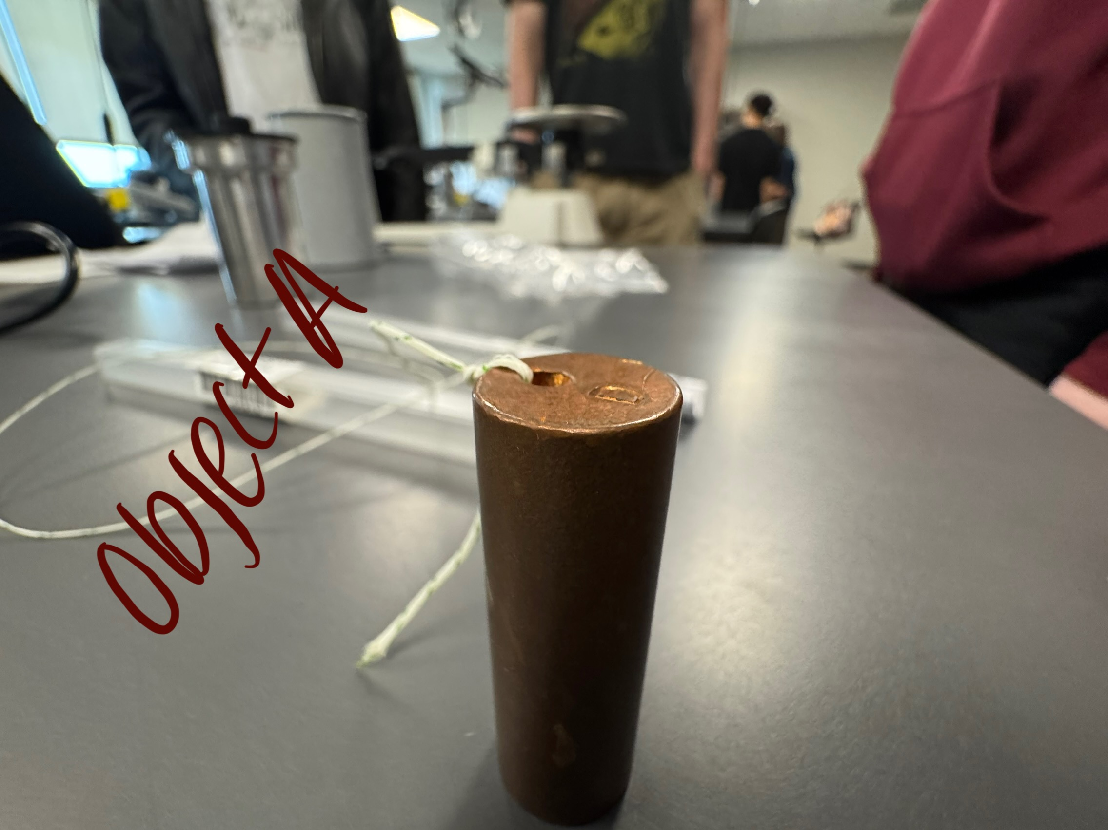
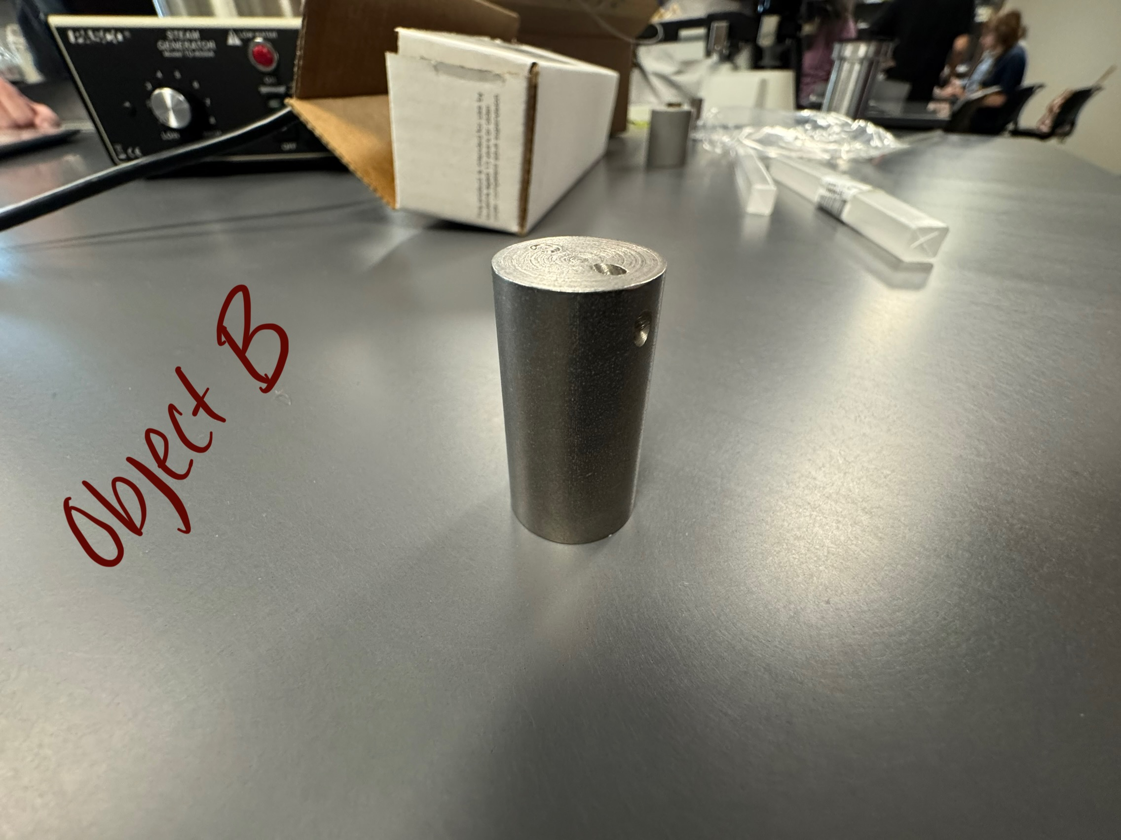
THEORY AND EQUATIONS:
The measurement of heat via the mixtures method uses the principle of equilibrium, where when you have two bodies of at different temperatures, the quantity of heat that’s lost by the hotter body becomes equal to the heat gained by the cooler body, resulting in both bodies reaching an equilibrium temperature.
Specific heat is defined as the quantity of heat (measured in calories or joules) that’s needed to raise the temperature of a substance by one degree. The units used for specific heat are J/kg.C. In this experiment, a metal object at a relatively higher temperature will be mixed into water, which is at a lower temperature. The final equilibrium temperature of the mixture will be measured along with the initial temperature of the metal and water. The material of the calorimeter will absorb some heat, so it will also be included in the calculations.
The specific heat, c, is given by:
|Heat gained by water and calorimeter| - |Heat lost by metal| = 0
Which yields:
$\left|M_{w}c_{w}(T_{e}-T_{iw})+M_{c}c_{c}(T_{e}-T_{ic})\right|-\left|M_{m}c_{m}(T_{im}-T_{e})\right|=0$
$M_{w}c_{w}(T_{e}-T_{iw})+M_{c}c_{c}(T_{e}-T_{ic})-M_{m}c_{m}(T_{e}-T_{im})=0$ (1)
$(M_{w}c_{w}+M_{c}c_{c})(T_{e}-T_{iw})+M_{m}c_{m}(T_{e}-T_{im})=0$ (2)
Where:
‘M’ is the mass, ‘C’ is the specific heat, subscript ‘w’ is water, ‘c’ is the calorimeter, and ‘m’ is the metal.
‘$T_{iw}$’ is the initial temperature of the water, ‘$T_{ic}$’ is the initial temperature of the calorimeter, and ‘$T_{im}$’ is the initial temperature of the metal
‘$T_{e}$’ is the final equilibrium temperature of the calorimeter, including all 3 materials.
Latent heat is the amount of heat that is required to change the unit mass of a substance from a solid state to a liquid state, or from a liquid state to a gaseous state without a change in temperature. The latent heat of fusion is the latent heat of a solid turning to a liquid. The SI units used for latent heat are J/kg. In this experiment, the temperature of the calorimeter plus water will be measured before and after mixing in ice. The masses and temperatures of the water and ice will be measured before and after mixing, Latent heat will be found from:
Heat lost by water and calorimeter = Heat gained by ice to warm up to 0℃ + Heat gained by ice at 0℃ to melt into water at 0℃ + heat gained by melted ice (water) to come to ‘$T_{e}$’
($M_{w}c_{w}$+$M_{c}c_{c}$)($T_{e}-T_{iw}$)+$M_{ice}c_{ice}$(0 - $T_{i-ice}$)+$M_{ice}L_{ice}$+$M_{ice}c_{w}$($T_{e}$- 0) = 0 (3)
The subscript ice refers to ice, ‘$T_{i-ice}$’ is the initial temperature of the ice, and ‘$L_{ice}$’ is the latent heat of fusion of ice.
PROCEDURE:
Specific heat:
- Weigh the empty calorimeter (inner cup only, Mc).
- Pour cold water in the calorimeter cup till it is about half full, and weigh it, and replace it in the insulating jacket. The temperature of this water should be about as many degrees lower (about 3ºC) than the room temperature water, as the final equilibrium temperature is expected to be above it. This will reduce the errors due to radiation heat loss.
- Record the temperature of the water (Tiw).
- Fill the boiler with enough water to cover the metal cylinder plus a few inches to spare. Place it on the heater. Turn on the heater, and let the water come to a boil.
- Weigh the metal object (Mm). Lower it in the boiling water by means of a thread. Make sure it is completely immersed, but not touching the sides or bottom of the boiler. Keep it in there till it comes to the temperature of the hot water (Tmi).
- Quickly but carefully transfer the metal object from the boiler to the calorimeter. Stir the water and record the equilibrium temperature.
- Measure and record the temperature of the boiling water.
Latent Heat:
- Repeat procedures 1, 2 and 3. The cold water should be about 10ºC above room temperature (since it is expected that the final equilibrium temperature to be about 10ºC below room temperature).
- Dry some pieces of ice on a paper towel and add them to the water in the calorimeter. Avoid touching the ice (to prevent melting).
- Stir the mixture. Record the equilibrium temperature (when ice is completely melted).
- Weigh the calorimeter with water and melted ice. The thermometer takes the temperature of the water that it is dipped in, but after taking it out, it cools down in air quite slowly.
DATA AND OBSERVATION:

Part 1(specific heat)
At the beginning of the experiment, before setting everything up, the first thing that was measured was the mass of the aluminum cylinder. After finding the mass, the next step was measuring the mass of the cylinder with water, and then the group took the measured mass of the solid piece of metal.
Once all the measured masses were taken, the next step was placing the calorimeter filled with water on the boiler for 6 minutes; the group knew the water would be ready once the desired steam came out from under the lid. With the group member in charge of checking the water, they made sure to steer clear of the steam that would come out once the lid was moved in order to avoid getting burned. Since the calorimeter is insulated, the group didn't have to worry about getting burned when moving it.
Once the desired amount of steam was observed, one member placed the thermometer into the water while making sure it didn't touch the bottom of the calorimeter, or else it wouldn't give the group the right temperature. The thermometer would stay in the water until the temperature reached equilibrium. Once the temperature equilibrium was reached, the aluminum cylinder was placed directly into the hot water. After the cylinder was in the water, a slight drop in temperature was noticed. Once a couple of seconds passed, the temperature would go back to equilibrium with the cylinder still inside. In the end, the aluminum cylinder was removed from the calorimeter, and the water inside was left to heat back up until equilibrium was reached again. This time, once the intended temperature was reached, the copper cylinder was placed into the water.

Part 2 (Latent heat)
During the second experiment, water measured to be 10 degrees above room temperature by a thermometer was placed into a small cylinder. The aluminum cylinder from the previous experiment was placed in the water, which resulted in its temperature rising. With the water's new temperature, it was then placed onto a triple-beam balance to measure its new mass without the thermometer. The thermometer was then placed into a cup with ice to get the thermometer's reading back to zero.
At the end of the experiment, a piece of ice was weighed on the triple balance beam, and once the mass was measured, it was then placed into the calorimeter where the new temperature was measured, and finally the mass of the melted ice with the calorimeter, water, and melted ice was taken.

CALCULATIONS:
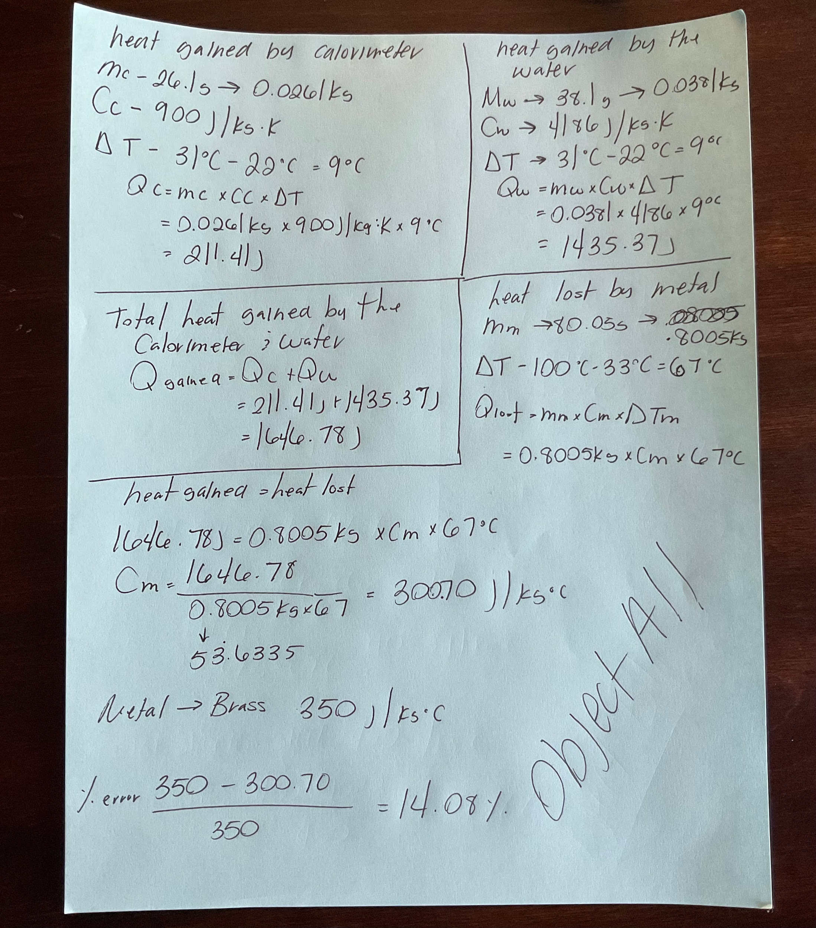
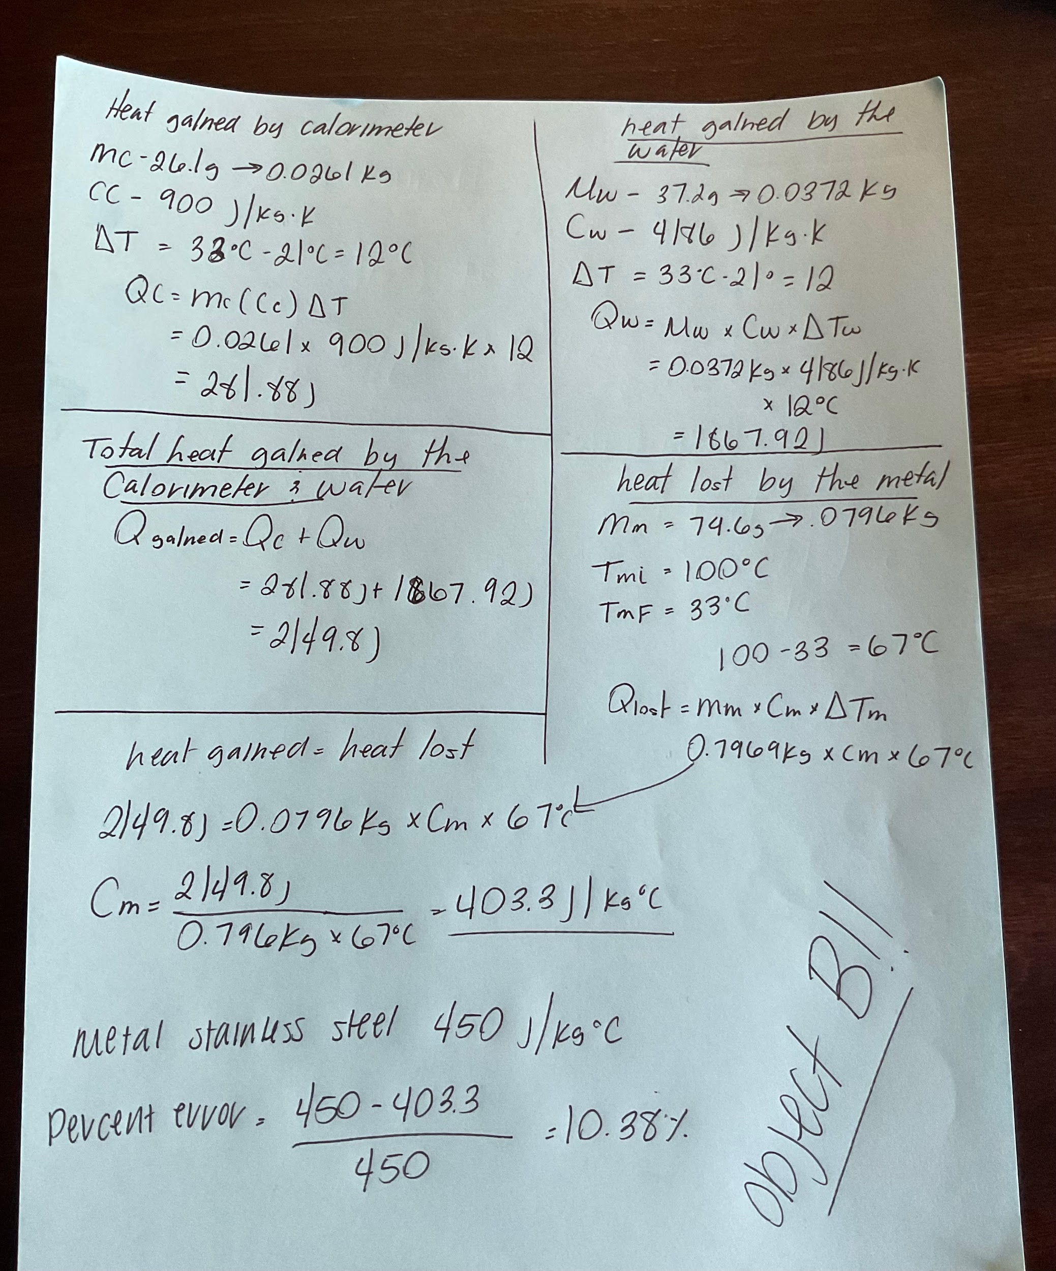
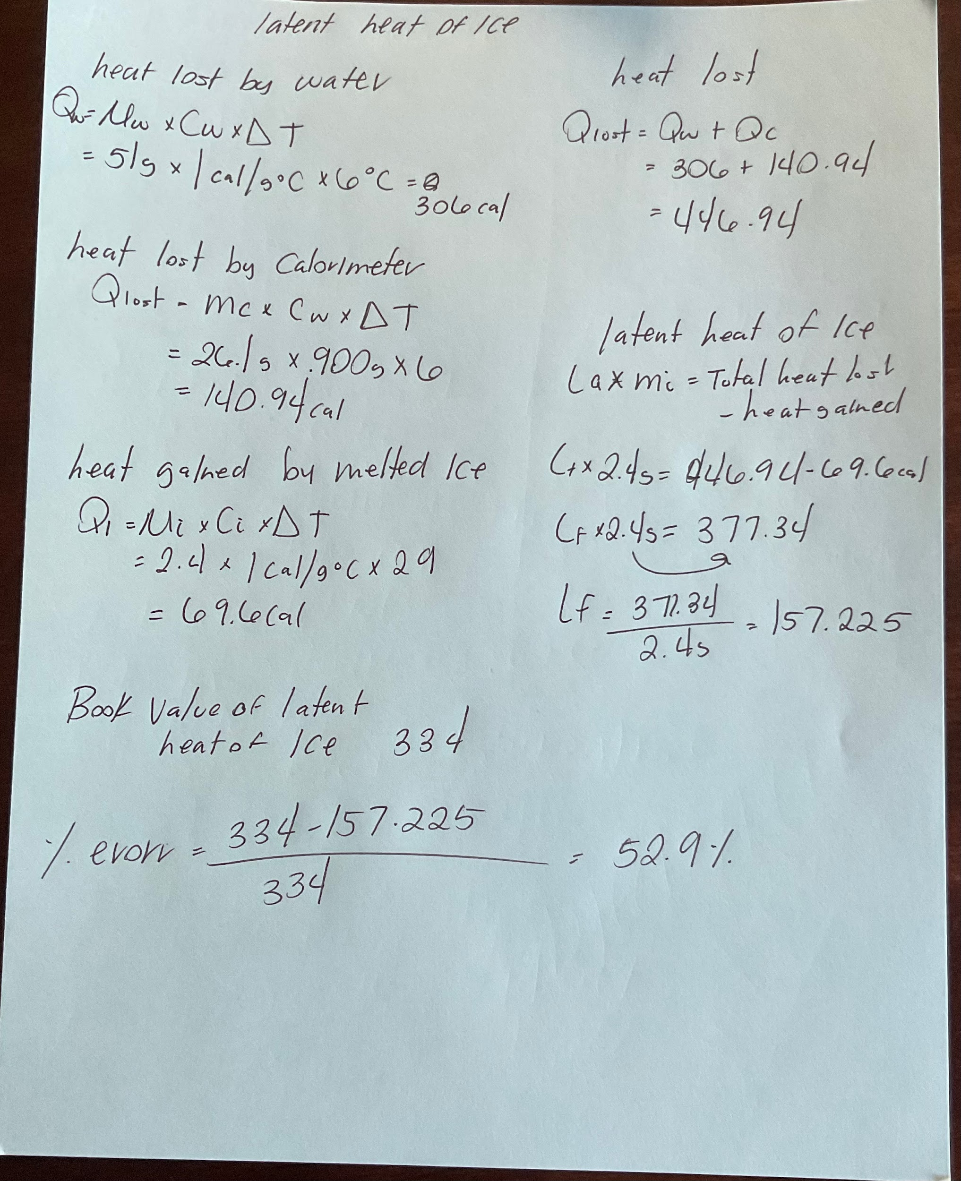
RESULTS:
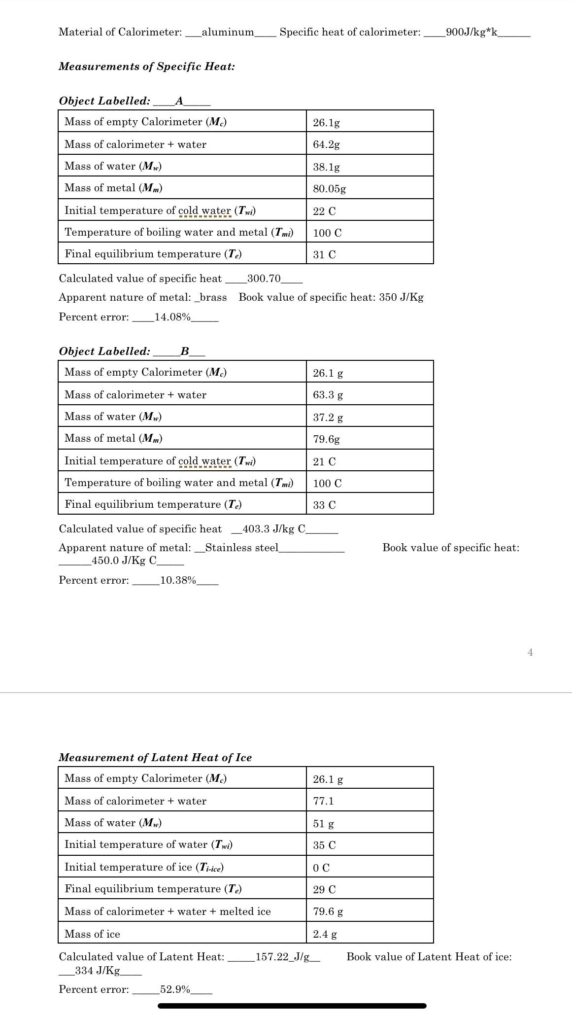
SOURCES OF ERROR:
- Imprecision in measurements. The measuring of the temperature and mass of the water and objects used in the experiment were all measured by eye and hand. This lack of precision can lead to errors when calculations are done.
- The mass of the string was not accounted for in the experiment which could lead to minor rounding errors.
- The ice was already partially melted before the experiment was performed and was quite small as it began. It may have melted some more after weighing due to its small size and being handled by hand affecting results.
DISCUSSION:
Using a calorimeter, this experiment determined the latent heat of ice fusion and the specific heat of metals. It was predicated on the idea that heat obtained by a cooled object is equal to heat lost by a hot one. The final equilibrium temperature was evaluated after heating a metal sample and submerging it in cooled water to determine specific heat. It was determined that the metal's specific heat using the mass and temperature information. The ice was melted in warm water and watched the temperature drop to determine latent heat. It was determined that the latent heat of ice fusion based on the temperature and mass changes. Delays in temperature readings or heat loss to the environment could have caused minor mistakes.

CONCLUSION:
The goal of this experiment was to measure the specific heat of metals, and the latent heat of fusion of ice, through heat balance. This goal was met by following the procedure and completing the lab. The results gathered were within a 15% error for the brass object and approximately a 10% error for the steel object. These were likely caused by the sources of error displayed during the experiment. The latent heat being the largest by having around a 50% error which was likely due to the sources of error concerning the handling of the ice during measurements. The hypothesis stated was supported by the data gathered. The key findings were the specific heat of the objects, which were measured by use of a thermometer and a triple beam balance to ascertain the temperature as the objects were transitioned into water of different temperatures and the mass.

